AP Biology
Unit 6: Gene Expression and Regulation
Suggested Duration: 16 Days
GENE EXPRESSION AND REGULATION

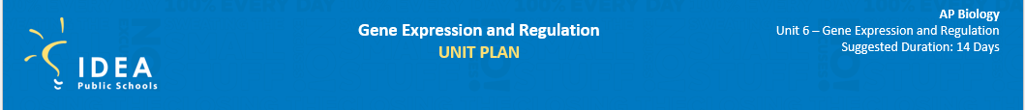
Table of Contents
UNIT NARRATIVE 1
CONTENT STANDARDS, UNDERSTANDINGS, AND QUESTIONS 2
ROADMAP 4
UNPACKED STANDARDS 17
VOCABULARY GLOSSARY 19

UNIT NARRATIVE
Progressing from the continuity of life to gene expression, in Unit 6 students gain in-depth knowledge about nucleic acids and their role in gene expression. Students receive a finer focus on the comparison between the structures of DNA and RNA. This unit highlights how an individual’s genotype is physically expressed through that individual’s phenotype. Understanding protein synthesis (transcription and translation) is vital to answering essential questions about gene expression. Regulation of gene expression and cell specialization are instrumental in ensuring survival within an individual and across populations. Unit 7 moves on to cover natural selection.

The ability to describe, analyze, and create models and representations to explain and/ or illustrate biological processes and make predictions about them is an important
skill for students to master. The primary learning goal in this unit is to create or use a representation/model to communicate biological phenomena, use the model to solve a problem, and refine the model or representation to analyze situations or solve problems. Throughout the course, students should have had multiple opportunities that involve making a claim, supporting it with evidence, and providing reasoning to support the claim. In this unit and throughout the course, students should become proficient in argumentation by predicting the causes or effects of a change in, or disruption to, one or more components in a biological system.

Students often do not understand the difference between a gene and an allele. Gene expression occurs at many levels, all of which are crucial in producing an organism’s
phenotype. Students can use the lac operon in E. coli to help them understand the significance of positive gene regulation. Often on the exam, students fail to provide reasoning connecting a change on the molecular level (e.g., a mutation) to a change in phenotype (e.g., an increase or decrease in protein levels). Students should understand that the location of a mutation in the codon can affect the structure and function of a protein. Common errors include stating that mutations result in the denaturation of a protein or that point mutations cause frameshift mutations. Students also tend to describe all mutations as having negative effects; exposure to examples of mutations that have no impact on phenotype can help prevent this misunderstanding.

UNDERSTANDINGS AND CONTENT STANDARDS
Below are the standards taught and assessed in this unit.
Topic
- Big Idea
  - Learning Objectives (Students will be able to…)
Topic 6.1 – DNA and RNA Structure
- Big Idea 3 – Information Storage and Transmission: Living systems store, retrieve, transmit, and respond to information essential to life processes.
  - 6.1.A: Describe the structures involved in passing heredity information from one generation to the next.
  - 6.1.B: Describe the characteristics of DNA that allow it to be used as the hereditary material.

Topic 6.2 – DNA Replication
- Big Idea 3 – Information Storage and Transmission: Living systems store, retrieve, transmit, and respond to information essential to life processes.
  - 6.2.A: Describe the mechanisms by which genetic information is copied for transmission between generations.

Topic 6.3 – Transcription and RNA Processing
- Big Idea 3 – Information Storage and Transmission: Living systems store, retrieve, transmit, and respond to information essential to life processes.
  - 6.3.A: Describe the mechanisms by which genetic information flows from DNA to RNA to protein.

Topic 6.4 – Translation
- Big Idea 3 – Information Storage and Transmission: Living systems store, retrieve, transmit, and respond to information essential to life processes.
  - 6.4.A: Describe how the phenotype of an organism is determined by its genotype.

Topic 6.5 – Regulation of Gene Expression
- Big Idea 3 – Information Storage and Transmission: Living systems store, retrieve, transmit, and respond to information essential to life processes.
  - 6.5.A: Describe the types of interactions that regulate gene expression.
  - 6.5.B: Explain how the location of regulatory sequences relates to their function.

Topic 6.6 – Gene Expression and Cell Specialization
- Big Idea 3 – Information Storage and Transmission: Living systems store, retrieve, transmit, and respond to information essential to life processes.
  - 6.6.A: Explain how the binding of transcription factors to promoter regions affects gene expression and the phenotype of the organism.
  - 6.6.B: Explain the connection between the regulation of gene expression and phenotypic differences in cells and organisms.

Topic 6.7 – Mutations
- Big Idea 3 – Information Storage and Transmission: Living systems store, retrieve, transmit, and respond to information essential to life processes.
  - 6.7.A: Describe the various types of mutations.
  - 6.7.B: Explain how changes in genotype may result in changes in phenotype.
  - 6.7.C: Explain how alterations in DNA sequence contribute to variation that can be subject to natural selection.

Topic 6.8 – Biotechnology
- Big Idea 3 – Information Storage and Transmission: Living systems store, retrieve, transmit, and respond to information essential to life processes.
  - 6.8.A: Explain the use of genetic engineering techniques in analyzing or manipulating DNA.

UNDERSTANDINGS AND QUESTIONS
Important big ideas and processes for the unit.
Key Questions
- What are the parts of a nucleotide?
- What is the structure of DNA?
- What is the structure of RNA?
- How does a nucleotide sequence specify a trait?
- What are the possible origins of the structure of DNA?
- How is RNA produced during transcription?
- How is protein produced during translation?
- What are the type of mutations and what would their possible consequences be?
- What is alternative splicing?
- What is an operon and how is it an example of gene regulation?
- What are ways in which bacterial DNA is transferred from one place to another?
- What are common ways in which humans use DNA technology to facilitate a process?
- What are mutations and how do they affect variation within a population?

ROADMAP
Suggested daily guide for instruction in this unit.

Lesson #1: DNA Structure and Function |  | Date:
Objective  SWBAT: Model the structure of DNA and RNA.  Standards  Topic 6.1: DNA and RNA Structure  Vocabulary  DNA  Adenine  Guanine  Cytosine  Thymine  Hydrogen bond  antiparallel  Science Practices  - Concept Explanation  - Visual Representations  - Argumentation | Instructional Notes  Activity 1: Making Claims About DNA and RNA Structure  Students will collaboratively work with their peers to create a “human” model of DNA. The teacher will lead a discussion while they are in this model stamping ideas such as: arrangement of the molecule, parts of the molecule, the sequence of the molecule determines our “traits” like hair color, skin color, eye color, etc., and where any potential mistakes have been made (A with a G, or C with a T, etc.) – these are called mutations. Students then create a stretch of RNA using the same technique.  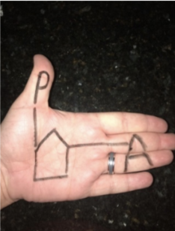  Activity 2: Students participate in an activity where they practice answering multiple choice and/or free response questions. For each free response question, they will complete a highlight and rewrite, and for each multiple choice, they will make a claim (choose the correct answer) and then provide evidence and reasoning on WHY the claim is correct. |  | Lesson Look Fors  Look for teachers to:  - Allow students to productively struggle with the content, using accountable talk moves to facilitate the lesson.  - Teachers should be walking around the room ensuring that students are engaged in all activities correctly, consistently monitoring for incorrect biology.  Look for students to:  - Engage in the hands-on-minds-on modeling activity.  - Ask clarifying questions regarding what they are learning.  - Write in complete sentences.  Students Do and Know
   | - Communicate finding to peers.  - Model the structure of DNA using “hand nucleotides.”
   | - Adenine naturally bonds with Thymine in a DNA molecules.  - Cytosine naturally bonds with Guanine in a DNA molecule.  - The three parts of a nucleotide are sugar, phosphate group, and nitrogenous base.  - Antiparallel means that each DNA strand runs 5’ to 3’ and the two strands run opposite of each other.  5’ GATTACA 3’  3’ CTAATGT 5’

Lesson #2: DNA Replication |  | Date:
Objective  SWBAT: Model the process of DNA replication.  Standards  Topic 6.2: DNA Replication  Vocabulary  Semiconservative  Helicase  Topoisomerase  Primer  Leading strand  Lagging strand  ligase  Science Practices  - Concept Explanation  - Visual Representations  - Argumentation | Instructional Notes  Part 1: DNA Replication Video  Students will watch a video on DNA replication, involving the following: directionality, semiconservative replication, leading and lagging strands, and the different enzymes involved: helicase, DNA polymerase, topoisomerase, and ligase.  Part 2: Modeling DNA structure  Students will use classroom materials to create a model of the DNA replication process. They must create their model, and then produce either a video of them narrating the process or you can choose to have them present to other groups. Either way you choose to do it, they must be exposed to other groups’ models and experience other students narrating the process.  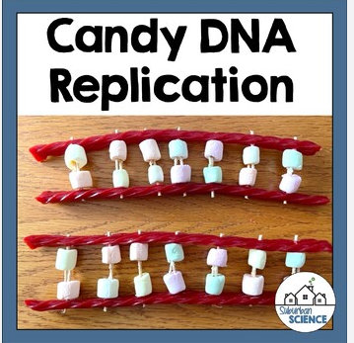 |  | Lesson Look Fors  Look for teachers to:  - Allow students to productively struggle with the content, using accountable talk moves to facilitate the lesson.  - Teachers should be walking around the room ensuring that students are engaged in all activities correctly, consistently monitoring for incorrect biology.  Look for students to:  - Engage in the hands-on-minds-on modeling activity.  - Ask clarifying questions regarding what they are learning.  - Write in complete sentences.  Students Do and Know
  - Derive meaning from a video
  - Create a model of the DNA replication process.
  - Narrate the model to other student groups.
  - DNA replication is a crucial part of the cell cycle because it ensures that each new cell, after mitosis, has the exact same DNA.
  - DNA is a nucleic acid made up of nucleotides.
  - Chargaff’s rules: adenine always bonds with thymine, and cytosine always bonds with guanine.
  - Semiconservative means that during DNA replication the resulting daughter strands each have one new strand and one strand that was a part of the mother strand.
  - Helicase unzips the DNA.
  - Topoisomerase allows the DNA to unwind.
  - During DNA replication, one new strand (the leading strand) is made as a continuous piece. The other (the lagging strand) is made in small pieces.

Lesson #3: Transcription |  | Date:
Objective  SWBAT: Model the process of transcription.  Standards  Topic 6.3: Transcription and RNA Processing  Vocabulary  mRNA  rRNA  tRNA  transcription  initiation  elongation  termination  template strand  noncoding strand  minus strand  antisense strand  RNA polymerase  Intron  Exon  Alternative splicing  Science Practices  - Concept Explanation  - Visual Representations  - Argumentation | Instructional Notes  Activity 1: Read to Learn  Students participate in a Read to Learn activity where they read an article about the process of transcription and answer questions regarding the process.  Activity #2: Modeling of Transcription  Students will use classroom materials to create a model of the transcription process. This should be an “add-on” to what they did yesterday in class when they replicated DNA.  They must create their model, and then produce either a video of them narrating the process or you can choose to have them present to other groups. Either way you choose to do it, they must be exposed to other groups’ models and experience other students narrating the process.  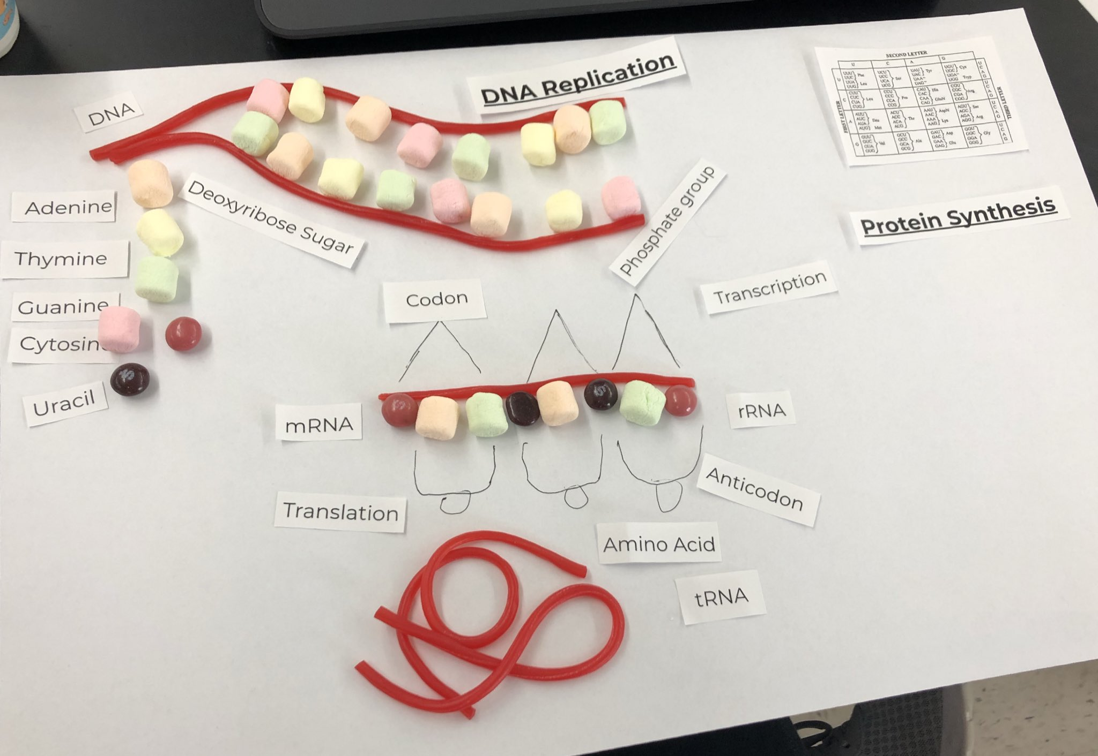 |  | Lesson Look Fors  Look for teachers to:  - Allow students to productively struggle with the content, using accountable talk moves to facilitate the lesson.  - Teachers should be walking around the room ensuring that students are engaged in all activities correctly, consistently monitoring for incorrect biology.  Look for students to:  - Engage in the hands-on-minds-on modeling activity.  - Ask clarifying questions regarding what they are learning.  - Write in complete sentences.  Students Do and Know
  - Derive meaning from a Read to Learn
  - Create a model of the transcription process.
  - Narrate the model to other student groups.
  - Transcription is the process of using DNA to produce a strand of RNA.
  - Alternative splicing is when certain parts of an mRNA strand are cut out (introns) and certain parts are left in (exons).
  - Initiation: The RNA polymerase enzyme binds to the promoter region of a gene, which signals the DNA to unwind.
  - Elongation: The RNA polymerase reads the unwound DNA strand and builds an mRNA molecule using complementary base pairs.
  - Termination: The RNA polymerase crosses a stop sequence in the gene, the mRNA strand detaches from the DNA, and transcription ends
Lesson #4: Translation |  | Date:
Objective  SWBAT: Model the process of transcription and translation.  Standards  Topic 6.4: Translation  Vocabulary  Translation  Initiation  Elongation  Termination  Genetic code  retroviruses  Science Practices  - Concept Explanation  - Visual Representations  - Argumentation | Instructional Notes  Activity 1: Read to Learn  Students participate in a Read to Learn activity where they read an article about the process of translation and answer questions regarding the process.  Activity #2: Modeling of Translation  Students will use classroom materials to create a model of the translation process. This should be an “add-on” to what they did the past two days in class when they replicated DNA and then created an mRNA strand from one of the daughter DNA strands.  They must create their model, and then produce either a video of them narrating the process or you can choose to have them present to other groups. Either way you choose to do it, they must be exposed to other groups’ models and experience other students narrating the process.  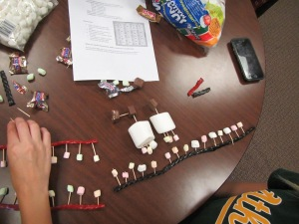 |  | Lesson Look Fors  Look for teachers to:  - Allow students to productively struggle with the content, using accountable talk moves to facilitate the lesson.  - Teachers should be walking around the room ensuring that students are engaged in all activities correctly, consistently monitoring for incorrect biology.  Look for students to:  - Engage in the hands-on-minds-on modeling activity.  - Ask clarifying questions regarding what they are learning.  - Write in complete sentences.  Students Do and Know
  - Derive meaning from a Read to Learn
  - Create a model of the translation process.
  - Narrate the model to other student groups.
  - Transcription is the process of using DNA to produce a strand of RNA.
  - Translation is the process of using RNA to produce a protein.
  - A mutation is a “mistake” in the DNA sequence.
  - Initiation: The ribosome, mRNA, and an initiator tRNA come together to form an initiation complex. This is the most complex step and varies among different kingdoms of life.
  - Elongation: Amino acids are brought to the ribosome by tRNAs and linked together to form a chain.
  - Termination: The ribosome reaches a stop codon, and a release factor binds to it. This causes the amino acid chain to be released and the ribosome subunits to separate

Lesson #5: Protein Synthesis Gizmo |  | Date:
Objective  SWBAT: Analyze data to determine what part of protein synthesis is disrupted and causing a girl’s illness.  Standards  Topic 6.3: Transcription and RNA Processing  Topic 6.4: Translation  Vocabulary  Transcription  Translation  Amino acid  mRNA  tRNA  nucleotides  genes  codon  ribosome  enhancer  promoter  terminator  transcription factor  Science Practices  - Concept Explanation  - Visual Representations  - Representing and Describing Data  - Argumentation | Instructional Notes  Learning Objectives: STEM Cases are designed to help students learn the core concepts and practice critical thinking skills (data analysis, data interpretation, hypothesis and reasoning, predictions and communicating findings). Students are assessed on each of these and their progress can be monitored in real time by teachers. The following concepts are addressed in the Protein Synthesis STEM Case:  - Protein synthesis, amino acids, protein folding, cell nucleus, DNA, nucleotides  - Transcription, translation, mRNA, tRNA, genes, codons, codon wheel, ribosomes  - Immune system function, white blood cells, immunodeficiency, HIV, ADA SCID, gene mutations, stem cell therapy  - AP Version Only: Structure of amino acids and side chains, gene regulation (enhancers, promoters, terminators) and transcription factors (activators and repressors)  Ensure you are using the “AP version.”  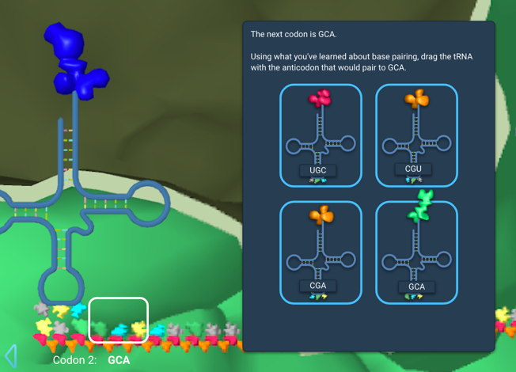 |  | Lesson Look Fors  Look for teachers to:  - Allow students to productively struggle with the content, using accountable talk moves to facilitate the lesson.  - Teachers should be walking around the room ensuring that students are engaged in all activities correctly, consistently monitoring for incorrect biology.  Look for students to:  - Engage in the hands-on-minds-on modeling activity.  - Ask clarifying questions regarding what they are learning.  - Write in complete sentences.  Students Do and Know
  - Utilize knowledge of protein synthesis to solve a real-world medical issue.
  - Communicate results with group members.
  - Transcription is the process of using DNA to produce a strand of RNA.
  - Translation is the process of using RNA to produce a protein.
  - A transcription promoter is a DNA sequence that signals where and how a gene should be transcribed.
  - A transcription factor is a protein that controls the rate at which DNA is transcribed into messenger RNA (mRNA).

Lesson #6: Protein Synthesis + RNA/Protein Processing |  | Date:
Objective  SWBAT: Describe how RNA is processed in eukaryotes before entering the process of translation.  Standards  Topic 6.3: Transcription and RNA Processing  Vocabulary  Transcription  mRNA processing  protein  spliceosome  exon  intron  Science Practices  - Concept Explanation  - Visual Representations  - Argumentation | Instructional Notes  Activity 1: Students watch a video on the steps of protein synthesis, which includes both RNA processing and protein processing while taking notes on the foldable.  Activity 2: Students will participate in a POGIL activity that summarizes their knowledge of:  - Transcription  - mRNA processing  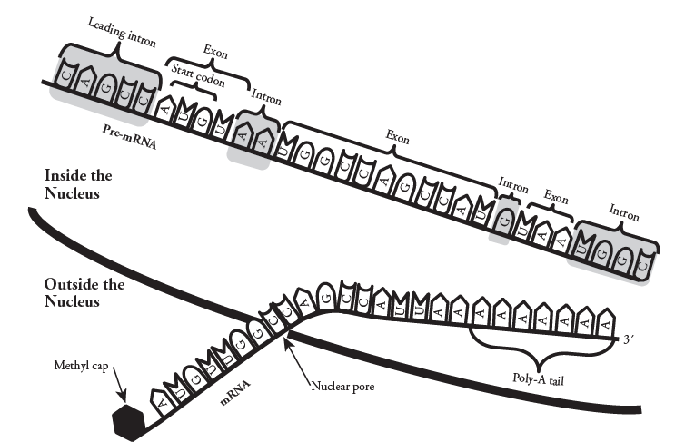 |  | Lesson Look Fors  Look for teachers to:  - Allow students to productively struggle with the content, using accountable talk moves to facilitate the lesson.  - Teachers should be walking around the room ensuring that students are engaged in all activities correctly, consistently monitoring for incorrect biology.  Look for students to:  - Engage in the hands-on-minds-on modeling activity.  - Ask clarifying questions regarding what they are learning.  - Write in complete sentences.  Students Do and Know
  - Derive meaning from a video on protein synthesis and RNA processing
  - Participate in the POGIL activity.
  - Messenger RNA (mRNA) processing is the process of modifying pre-mRNA into mature mRNA before it is translated into a polypeptide.
  - The steps of mRNA processing include: (1) Splicing: Introns, which are non-coding regions of the mRNA, are removed and exons, which are coding regions, are joined together. This process is carried out by spliceosomes, which are complexes of RNA molecules and proteins; (2) Capping: A 5' cap is added to the mRNA; (3) Poly-A tail: A long string of adenosines is added to the 3' end of the mRNA; and (4) Export: The mature mRNA is exported through nuclear pores into the cytoplasm for translation.

Lesson #7: Operons |  | Date:
Objective  SWBAT: Predict the effects on lactose metabolism when the concentration of lactose is changed.  Standards  Topic 6.5: Regulation of Gene Expression  Topic 6.6: Gene Expression and Cell Specialization  Vocabulary  Operon  Lac operon  Trp operon  RNA polymerase  mRNA  translation  regulatory genes  promoter  operator  structural genes  repressor  Science Practices  - Concept Explanation  - Visual Representations  - Questions and Methods  - Representing and Describing Data  - Argumentation | Instructional Notes  The Lac Operon simulation will provide you with a realistic interactive model of the bacterial lac operon. The lac operon is a set of genes which are responsible for the production of proteins (enzymes) important for regulating the import and utilization metabolism of lactose by some bacterial cells, for example E.coli. The simulation is designed to mimic the cellular systems that control this operon and ultimately control the production of the enzymes and lactose metabolism. The simulation will also allow you to explore the effects of mutations within the operon and other related genes.  Students will be able to:  - Predict the effects on lactose metabolism when the various genes and DNA control elements are mutated (added or removed).  - Predict the effects on lactose metabolism when the concentration of lactose is changed.  - Explain the roles of LacI, LacZ, and LacY in lactose regulation.  - Use evidence to defend your ideas.  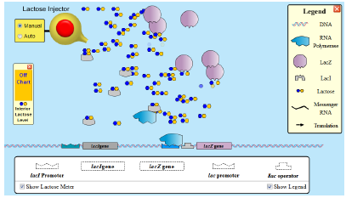 |  | Lesson Look Fors  Look for teachers to:  - Allow students to productively struggle with the content, using accountable talk moves to facilitate the lesson.  - Teachers should be walking around the room ensuring that students are engaged in all activities correctly, consistently monitoring for incorrect biology.  Look for students to:  - Engage in the hands-on-minds-on modeling activity.  - Ask clarifying questions regarding what they are learning.  - Write in complete sentences.  Students Do and Know
  - Create a model of the lac operon.
  - Use a model to investigate the effects certain factors have on lactose metabolism.
  - An operon is a group of genes in DNA that are transcribed together to create a single messenger RNA (mRNA) molecule. The genes in an operon are usually functionally related and are often involved in the same biochemical pathway.
  - Promoter is a DNA sequence where the RNA polymerase binds to initiate transcription. Operator is the DNA segment where the repressor molecule binds to the operon model.
  - The lac repressor is a protein that represses (inhibits) transcription of the lac operon.

Lesson #8: HHMI Mutations Activity |  | Date:
Objective  SWBAT: Describe how changes in DNA can lead to changes in phenotype.  Standards  Topic 5.5: Environmental Effects on Phenotype  Topic 6.7: Mutations  Vocabulary  Mutation  Transcription  Translation  Variation  Substitution mutation  Insertion mutation  Deletion mutation  Missense mutation  Silent mutation  Nonsense mutation  Science Practices  - Concept Explanation  - Visual Representations  - Questions and Methods  - Representing and Describing Data  - Argumentation | Instructional Notes  HHMI Activity: Students participate in the Molecular Genetics of Color Mutations in Rock Pocket Mice activity.  In these activities, students transcribe and translate portions of the rock pocket mouse Mc1r gene to further explore the genetic variations responsible for different coat colors as described in the short film Making of the Fittest: Natural Selection and Adaptation.  By comparing DNA sequences, students identify the locations and types of mutations responsible for the coat-color change described in the film. Students will form a hypothesis to explain how a change in amino acid sequence affects the functionality of the MC1R protein, and how that change might directly affect the coat color of the rock pocket mouse populations. Activity 1 is a basic version of the activity appropriate for first-year high school biology students.  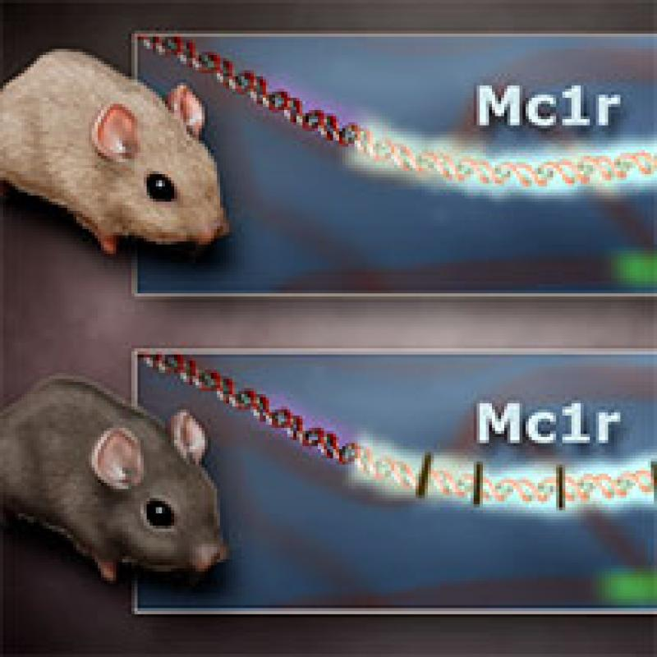 |  | Lesson Look Fors  Look for teachers to:  - Allow students to productively struggle with the content, using accountable talk moves to facilitate the lesson.  - Teachers should be walking around the room ensuring that students are engaged in all activities correctly, consistently monitoring for incorrect biology.  Look for students to:  - Engage in the hands-on-minds-on modeling activity.  - Ask clarifying questions regarding what they are learning.  - Write in complete sentences.  Students Do and Know
  - Analyze data in the simulation.
  - Make appropriate conclusions based on data analysis.
  - A mutation is a change in the DNA sequence.
  - A deletion involves a removal of a part. A substitution is a mutation where one or more nucleotides are substituted for others. An insertion is the addition of nucleotides.
  - A silent mutation is one that does not have an effect on the protein created.
  - A missense mutations causes the protein created in translation to be different.
  - A nonsense mutation causes protein synthesis to stop.

Lesson #9: Prokaryotic Movement of Genetic Information |  | Date:
Objective  SWBAT: Describe how DNA is moved from one place to another using the processes of transformation, transduction, conjugation, and transposition.  Standards  Topic 6.7: Mutations  Vocabulary  Transformation  Transduction  Conjugation  Transposition  Science Practices  - Concept Explanation  - Visual Representations  - Argumentation | Instructional Notes  Activity #1: Students participate in a Read to Learn regarding the following prokaryotic processes that move DNA from one place to another, which increases genetic variation:  - Transformation  - Transduction  - Conjugation  - Transposition  Activity #2: Students will participate in a card sort activity involving these prokaryotic processes.  Activity #3: Students participate in a highlight and rewrite activity. A HLRW activity is one where students answer a prompt, then highlight where they got points, analyze where they were correct and where they missed the mark, and then rewrite with a perfect response.  - Teacher hands student a free response prompt.  - Students answer the question to the best of their ability.  - Teacher gives students the rubric by which the question should be scored on and then takes a highlighter and highlights everywhere in their writing that earned a point. The teacher can help clarify if individual students have questions.  - Students then analyze their answer for the following:  - Where did I earn points, and why was I able to earn them?  - Where did I not earn points, and why was I not able to earn them?  - What vocabulary and/or concepts did I not know and/or got confused on?  - Then, the student takes their analysis, along with the rubric, and writes a perfect response. |  | Lesson Look Fors  Look for teachers to:  - Allow students to productively struggle with the content, using accountable talk moves to facilitate the lesson.  - Teachers should be walking around the room ensuring that students are engaged in all activities correctly, consistently monitoring for incorrect biology.  Look for students to:  - Engage in the hands-on-minds-on modeling activity.  - Ask clarifying questions regarding what they are learning.  - Write in complete sentences.  Students Do and Know
  - Derive meaning from a Read to Learn.
  - Match processes up with their description.
  - Create written answers to AP Biology free response questions.
  - Bacterial transformation is a process that introduces foreign DNA into bacterial cells, giving them new genetic traits.
  - Bacterial transduction is a process by which a bacteriophage, or bacterial virus, transfers genetic material from one bacterium to another.
  - Bacterial conjugation is a process that allows bacteria to transfer genetic material to one another through direct contact or a bridge-like connection.
  - Bacterial transposition is a process that moves genetic elements, called transposons, within a bacterial genome.

Lesson #10: DNA Profiling Gizmo |  | Date:
Objective  SWBAT: Design a DNA profiling test and use it to help solve crimes and determine parentage.  Standards  Topic 6.8: Biotechnology  Vocabulary  DNA polymerase  gel electrophoresis  gene  mutation  non-coding region  polymerase chain reaction (PCR)  primer  short tandem repeat  Science Practices  - Concept Explanation  - Visual Representations  - Questions and Methods  - Representing and Describing Data  - Statistical Tests and Data Analysis  - Argumentation | Instructional Notes  Learning Objectives  Students will …  - Identify the differences in DNA between people that can help in DNA profiling analysis.  - Create a DNA profiling test by designing primers that amplify useful sections of DNA.  - Use the DNA profiling test they designed to help solve crimes and determine parentage.  Lesson Overview  In the DNA Profiling Gizmo, students will investigate the  differences in DNA that allow individuals to be identified by a DNA profiling analysis. Students will design their own DNA analysis test, then use this test to investigate crime scene evidence, match DNA to suspects, and determine paternity and maternity.  The Student Exploration sheet contains three activities:  - Activity A – Students learn the techniques of polymerase chain reaction (PCR) and gel electrophoresis (GE) to distinguish DNA segments by length.  - Activity B – Students create and test primers used to copy specific segments of DNA.  - Activity C – Students use the DNA profiling test they created to solve crimes and determine parentage.  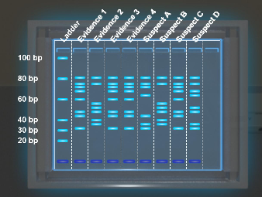 |  | Lesson Look Fors  Look for teachers to:  - Allow students to productively struggle with the content, using accountable talk moves to facilitate the lesson.  - Teachers should be walking around the room ensuring that students are engaged in all activities correctly, consistently monitoring for incorrect biology.  Look for students to:  - Engage in the hands-on-minds-on modeling activity.  - Ask clarifying questions regarding what they are learning.  - Write in complete sentences.  Students Do and Know
  - Analyze experimental data to make appropriate conclusions.
  - Electrophoresis is a laboratory technique used to separate DNA, RNA or protein molecules based on their size and electrical charge.
  - Polymerase chain reaction (PCR) is a laboratory technique that amplifies a specific DNA or RNA segment to make it possible to study it in detail.
Lesson #11: Lab Review Practice |  | Date:
Objective  SWBAT: Analyze simulated data and make informed conclusions from two experiments: transformation and restriction enzymes.  Standards  Topic 6.8: Biotechnology  Vocabulary  Transformation  Restriction enzyme  Electrophoresis  Plasmid  Science Practices  - Concept Explanation  - Visual Representations  - Questions and Methods  - Representing and Describing Data  - Statistical Tests and Data Analysis  - Argumentation | Instructional Notes  Activity #1: Students are introduced to the AP Biology Transformation Lab. They will then participate in a lab review activity where they analyze simulated data and make appropriate conclusions.  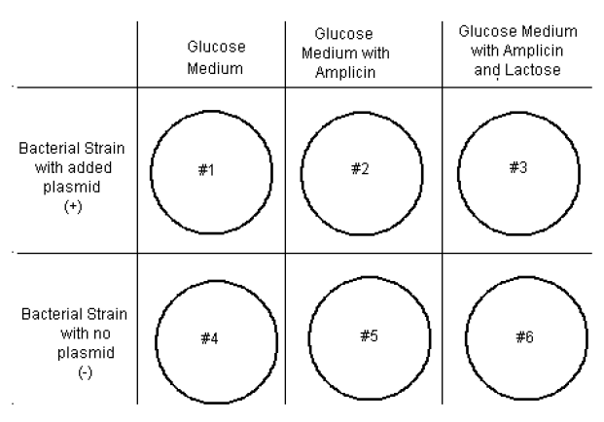  Activity #2: Students are introduced to the AP Biology Restriction Enzyme Lab. They will then participate in a lab review activity where they analyze simulated data and make appropriate conclusions.  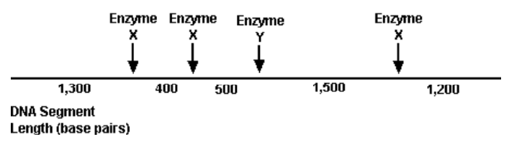 |  | Lesson Look Fors  Look for teachers to:  - Allow students to productively struggle with the content, using accountable talk moves to facilitate the lesson.  - Teachers should be walking around the room ensuring that students are engaged in all activities correctly, consistently monitoring for incorrect biology.  Look for students to:  - Engage in the hands-on-minds-on modeling activity.  - Ask clarifying questions regarding what they are learning.  - Write in complete sentences.  Students Do and Know
  - Analyze experimental data to make appropriate conclusions.
  - Bacterial transformation is a process that introduces foreign DNA into bacterial cells, giving them new genetic traits.
  - Electrophoresis is a laboratory technique used to separate DNA, RNA or protein molecules based on their size and electrical charge.
  - A plasmid is a small, circular DNA molecule that can replicate independently of a cell's chromosomal DNA.
  - A restriction enzyme is a protein isolated from bacteria that cleaves DNA sequences at sequence-specific sites, producing DNA fragments with a known sequence at each end.

Lesson #12: Highlight and Rewrite Activity |  | Date:
Objective  SWBAT: Communicate in written form how genes are expressed and how variation is increased throughout the processes involved.  Standards  Topics 6.1 – 6.8  Vocabulary  All vocabulary involved in this unit  Science Practices  - Concept Explanation  - Visual Representations  - Questions and Methods  - Representing and Describing Data  - Statistical Tests and Data Analysis  - Argumentation | Instructional Notes  Today is all about practicing multiple choice and free response questions. Students will participate in multiple choice activities, as well as highlight and rewrite activities involving practice free response questions.  For the multiple-choice practice questions, students will have to correctly answer the question AND they will have to provide a justification of why the correct answer is not correct and why the incorrect answers are not correct.  For the free response practice questions students will participate in highlight and rewrite activities. A HLRW activity is one where students answer a prompt, then highlight where they got points, analyze where they were correct and where they missed the mark, and then rewrite with a perfect response.  - Teacher hands student a free response prompt.  - Students answer the question to the best of their ability.  - Teacher gives students the rubric by which the question should be scored on and then takes a highlighter and highlights everywhere in their writing that earned a point. The teacher can help clarify if individual students have questions.  - Students then analyze their answer for the following:  - Where did I earn points, and why was I able to earn them?  - Where did I not earn points, and why was I not able to earn them?  - What vocabulary and/or concepts did I not know and/or got confused on?  - Then, the student takes their analysis, along with the rubric, and writes a perfect response. |  | Lesson Look Fors  Look for teachers to:  - Allow students to productively struggle with the content, using accountable talk moves to facilitate the lesson.  - Teachers should be walking around the room ensuring that students are engaged in all activities correctly, consistently monitoring for incorrect biology.  Look for students to:  - Engage in the hands-on-minds-on modeling activity.  - Ask clarifying questions regarding what they are learning.  - Write in complete sentences.  Students Do and Know
  - Create written answers to AP Biology free response questions.
  - All concepts from this unit are fair game for these practice questions.

Day 13 | Review for Unit 6 Exam
Day 14 | Unit 6 Exam

UNPACKED STANDARDS
Focus standards for this unit.

Standards Clarification
Standards | Specificity | Notes/Explanations/Examples
6.1.A: Describe the structures involved in passing heredity information from one generation to the next. | Cognition: Describe  Content: Provide relevant characteristics of a specified topic. | Suggested Skill  - Concept Explanation (SP 1.C) – Explain biological concepts, processes, and/or models in applied contexts.  Classroom Resources:  - From Gene to Protein – A Historical Perspective  - Rosalind Franklin: She’s Worth Another Look
6.1.B: Describe the characteristics of DNA that allow it to be used as the hereditary material.
6.2.A: Describe the mechanisms by which genetic information is copied for transmission between generations. |  | Suggested Skill  - Visual Representations (SP 2.B.b) – Explain relationships between different characteristics of biological concepts, processes, or models represented visually in applied contexts.  Classroom Resources:  - From Gene to Protein – A Historical Perspective
6.3.A: Describe the mechanisms by which genetic information flows from DNA to RNA to protein.
6.4.A: Describe how the phenotype of an organism is determined by its genotype. |  | Suggested Skills  - Visual Representations (SP 2.D.b) – Represent relationships within biological models, including diagrams.  - Argumentation (SP 6.E.a) – Predict the causes and effects of a change in, or disruption to, one or more components in a biological system based on biological concepts.  Classroom Resources:  - From Gene to Protein – A Historical Perspective
6.5.A: Describe the types of interactions that regulate gene expression. |  | Suggested Skills  - Argumentation (SP 6.A) – Make a scientific claim.  Classroom Resources:  From Gene to Protein – A Historical Perspective
6.5.B: Explain how the location of regulatory sequences relates to their function. | Cognition: Explain  Content: Provide information about how or why a relationship, process, pattern, position, situation, or outcome occurs, using evidence and/or reasoning to support or qualify a claim. Explain “how” typically requires analyzing the relationship, process, pattern, position, situation, or outcome; whereas explain “why” typically requires analysis of motivations or reasons for the relationship, process, pattern, position, situation, or outcome.
6.6.A: Explain how the binding of transcription factors to promoter regions affects gene expression and the phenotype of the organism. |  | Suggested Skills  - Argumentation (SP 6.B) – Support a claim with evidence from biological principles, concepts, processes, and/or data.  Classroom Resources:  - From Gene to Protein – A Historical Perspective
6.6.B: Explain the connection between the regulation of gene expression and phenotypic differences in cells and organisms.
6.7.A: Describe the various types of mutations. | Cognition: Describe  Content: Provide relevant characteristics of a specified topic. | Suggested Skills  - Visual Representations (SP 2.C) – explain how biological concepts or processes represented visually relate to larger biological principles, concepts, processes, or theories.  Classroom Resources:  - From Gene to Protein – A Historical Perspective  Illustrative examples  - Mutations in the CFTR gene disrupt ion transport and results in cystic fibrosis.  - Mutations in the MC1R gene give adaptive melanism in pocket mice.  - Sickle cell anemia
6.7.B: Explain how changes in genotype may result in changes in phenotype. | Cognition: Explain  Content: Provide information about how or why a relationship, process, pattern, position, situation, or outcome occurs, using evidence and/or reasoning to support or qualify a claim. Explain “how” typically requires analyzing the relationship, process, pattern, position, situation, or outcome; whereas explain “why” typically requires analysis of motivations or reasons for the relationship, process, pattern, position, situation, or outcome.
6.7.C: Explain how alterations in DNA sequence contribute to variation that can be subject to natural selection.
6.8.A: Explain the use of genetic engineering techniques in analyzing or manipulating DNA. |  | Suggested Skills  - Argumentation (SP 6.D) – explain the relationship between experimental results and larger biological concepts, processes, or theories.  Classroom Resources:  - Gel Electrophoresis Lab  - Transformation Lab  - Visualizing Information  Illustrative Examples:  - Amplified DNA fragments can be used to identify organisms and perform phylogenetic analyses.  - Analysis of DNA can be used for forensic identification.  - Genetically modified organisms include transgenic animals.  - Gene cloning allows propagation of DNA fragments.

VOCABULARY GLOSSARY
Domain-specific words and definitions for this unit.
Key Content Vocabulary
DNA – a self-replicating material that is present in nearly all living organisms as the main constituent of chromosomes. It is the carrier of genetic information.

RNA – ribonucleic acid, a nucleic acid present in all living cells. Its principal role is to act as a messenger carrying instructions from DNA for controlling the synthesis of proteins, although in some viruses RNA rather than DNA carries the genetic information.

DNA replication – Replication occurs in three major steps: the opening of the double helix and separation of the DNA strands, the priming of the template strand, and the assembly of the new DNA segment. ... Finally, a special enzyme called DNA polymerase organizes the assembly of the new DNA strands.

Protein synthesis – Protein synthesis is the process of creating protein molecules. In biological systems, it involves amino acid synthesis, transcription, translation, and post-translational events. ... In translation, the amino acids are linked together in a particular order based on the genetic code.

Translation – In biology, translation is a step in protein biosynthesis where a genetic code from a strand of mRNA is decoded to produce a particular sequence of amino acids.

Transcription – In biology, transcription is the process of transcribing or making a copy of the genetic information stored in a DNA strand into a complementary strand of RNA (messenger RNA or mRNA) with the aid of RNA polymerases.

Semi-conservative model – During DNA replication the new daughter strands are a mixture of one parent strand and a newly created strand

DNA polymerase – Polymerases are enzymes that assist in synthesizing long chains of nucleic acids. There are DNA polymerases and RNA polymerases. DNA polymerases are those that are involved in template-directed synthesis of DNA from deoxyribonucleotide triphosphates.

Helicase – An enzyme that utilizes energy from nucleoside triphosphate (e.g., ATP) hydrolysis in order to unwind the two annealed nucleic acid strands (e.g., DNA)

Topoisomerase – Topoisomerases (or DNA topoisomerases) are enzymes that participate in the overwinding or underwinding of DNA. The winding problem of DNA arises due to the intertwined nature of its double-helical structure. During DNA replication and transcription, DNA becomes overwound ahead of a replication fork.

5’ 3’ direction – DNA is synthesized in the 5’ to 3’ direction.

Ligase – In biochemistry, a ligase is an enzyme that can catalyze the joining (ligation) of two large molecules by forming a new chemical bond. ... Ligase can join two complementary fragments of nucleic acid and repair single stranded breaks that arise in double stranded DNA during replication.

Okazaki fragments – Okazaki fragments are short sequences of DNA nucleotides (approximately 150 to 200 base pairs long in eukaryotes) which are synthesized discontinuously and later linked together by the enzyme DNA ligase to create the lagging strand during DNA replication.

Leading strand – The leading strand is the strand of nascent DNA which is synthesized in the same direction as the growing replication fork. The synthesis of leading strand is continuous. The lagging strand, on the other hand, is the strand of new DNA whose direction is opposite to the direction of the growing replication fork.

Lagging strand – On the lagging strand, DNA synthesis restarts many times as the helix unwinds, resulting in many short fragments called “Okazaki fragments.” DNA ligase joins the Okazaki fragments together into a single DNA molecule. ... RNA primers are removed and replaced with DNA by DNA polymerase I.

mRNA – Messenger RNA (mRNA) is a single-stranded RNA molecule that is complementary to one of the DNA strands of a gene. The mRNA is an RNA version of the gene that leaves the cell nucleus and moves to the cytoplasm where proteins are made. During protein synthesis, an organelle called a ribosome moves along the mRNA, reads its base sequence, and uses the genetic code to translate each three-base triplet, or codon, into its corresponding amino acid.

tRNA – Transfer ribonucleic acid (tRNA) is a type of RNA molecule that helps decode a messenger RNA (mRNA) sequence into a protein. ... When a tRNA recognizes and binds to its corresponding codon in the ribosome, the tRNA transfers the appropriate amino acid to the end of the growing amino acid chain.

rRNA – Messenger RNA (mRNA) is a single-stranded RNA molecule that is complementary to one of the DNA strands of a gene. The mRNA is an RNA version of the gene that leaves the cell nucleus and moves to the cytoplasm where proteins are made. During protein synthesis, an organelle called a ribosome moves along the mRNA, reads its base sequence, and uses the genetic code to translate each three-base triplet, or codon, into its corresponding amino acid.

Codon – a sequence of three nucleotides which together form a unit of genetic code in a DNA or RNA molecule.

lac operon – The lactose operon (lac operon) is an operon required for the transport and metabolism of lactose in E. coli and many other enteric bacteria. ... The gene product of lacZ is β-galactosidase which cleaves lactose, a disaccharide, into glucose and galactose.

trp operon – The trp operon, found in E. coli bacteria, is a group of genes that encode biosynthetic enzymes for the amino acid tryptophan. The trp operon is expressed (turned "on") when tryptophan levels are low and repressed (turned "off") when they are high. The trp operon is regulated by the trp repressor.

operon – In genetics, an operon is a functioning unit of DNA containing a cluster of genes under the control of a single promoter

poly A tail – The poly-A tail makes the RNA molecule more stable and prevents its degradation. Additionally, the poly-A tail allows the mature messenger RNA molecule to be exported from the nucleus and translated into a protein by ribosomes in the cytoplasm.

GTP cap – The central paradigm of microtubule biology is that microtubules are stabilized by a 'GTP cap', a region at the end of a polymerizing microtubule where GTP hydrolysis has not yet occurred. Direct measurement of the size of this cap in cells was never previously possible.

Introns – a segment of a DNA or RNA molecule which does not code for proteins and interrupts the sequence of genes.

Exons – a segment of a DNA or RNA molecule containing information coding for a protein or peptide sequence.

Inducible operon – An inducible operon is one whose expression increases quantitatively in response to an enhancer, an inducer, or a positive regulator.

Repressible operon – Genes in an operon are transcribed as a group and have a single promoter. ... Some operons are inducible, meaning that they can be turned on by the presence of a particular small molecule. Others are repressible, meaning that they are on by default but can be turned off by a small molecule.

Epigenetics – Epigenetics is the study of how your behaviors and environment can cause changes that affect the way your genes work. Unlike genetic changes, epigenetic changes are reversible and do not change your DNA sequence, but they can change how your body reads a DNA sequence.

RNA polymerase – RNA polymerase is an enzyme that is responsible for copying a DNA sequence into an RNA sequence, during the process of transcription.

Mutations – the changing of the structure of a gene, resulting in a variant form that may be transmitted to subsequent generations, caused by the alteration of single base units in DNA, or the deletion, insertion, or rearrangement of larger sections of genes or chromosomes.

Substitution mutation – Substitution is a type of mutation where one base pair is replaced by a different base pair. The term also refers to the replacement of one amino acid in a protein with a different amino acid.

Frameshift mutation – A frameshift mutation is a genetic mutation caused by a deletion or insertion in a DNA sequence that shifts the way the sequence is read. A DNA sequence is a chain of many smaller molecules called nucleotides.

Deletion mutation – Deletion is a type of mutation involving the loss of genetic material. It can be small, involving a single missing DNA base pair, or large, involving a piece of a chromosome.

Duplication – Duplication is a type of mutation that involves the production of one or more copies of a gene or region of a chromosome. Gene and chromosome duplications occur in all organisms, though they are especially prominent among plants. Gene duplication is an important mechanism by which evolution occurs.

Inversion – An inversion occurs when a chromosome breaks in two places; the resulting piece of DNA is reversed and re-inserted into the chromosome. Genetic material may or may not be lost as a result of the chromosome breaks.

Translocation – A translocation occurs when a piece of one chromosome breaks off and attaches to another chromosome. This type of rearrangement is described as balanced if no genetic material is gained or lost in the cell. If there is a gain or loss of genetic material, the translocation is described as unbalanced .

Electrophoresis – the movement of charged particles in a fluid or gel under the influence of an electric field.

Genetic engineering – the deliberate modification of the characteristics of an organism by manipulating its genetic material.

Bacterial transformation – Bacterial transformation is a process of horizontal gene transfer by which some bacteria take up foreign genetic material (naked DNA) from the environment. ... The process of gene transfer by transformation does not require a living donor cell but only requires the presence of persistent DNA in the environment.

Viral transduction – is a biological phenomenon by which genetic material (DNA) is transferred from one bacterium to another by a virus.

Conjugation – Conjugation is the process by which one bacterium transfers genetic material to another through direct contact. During conjugation, one bacterium serves as the donor of the genetic material, and the other serves as the recipient. The donor bacterium carries a DNA sequence called the fertility factor, or F-factor.

